Solution Architecture

|  |  |
| --- | --- |
| Date | 19 November 2022 |
| Team ID | PNT2022TMID50196 |
| Project Name | **Exploratory Analysis of RainFall Data in India for Agriculture** |
| Maximum Marks | 2 Marks |

**Minimum Viable Architecture:**

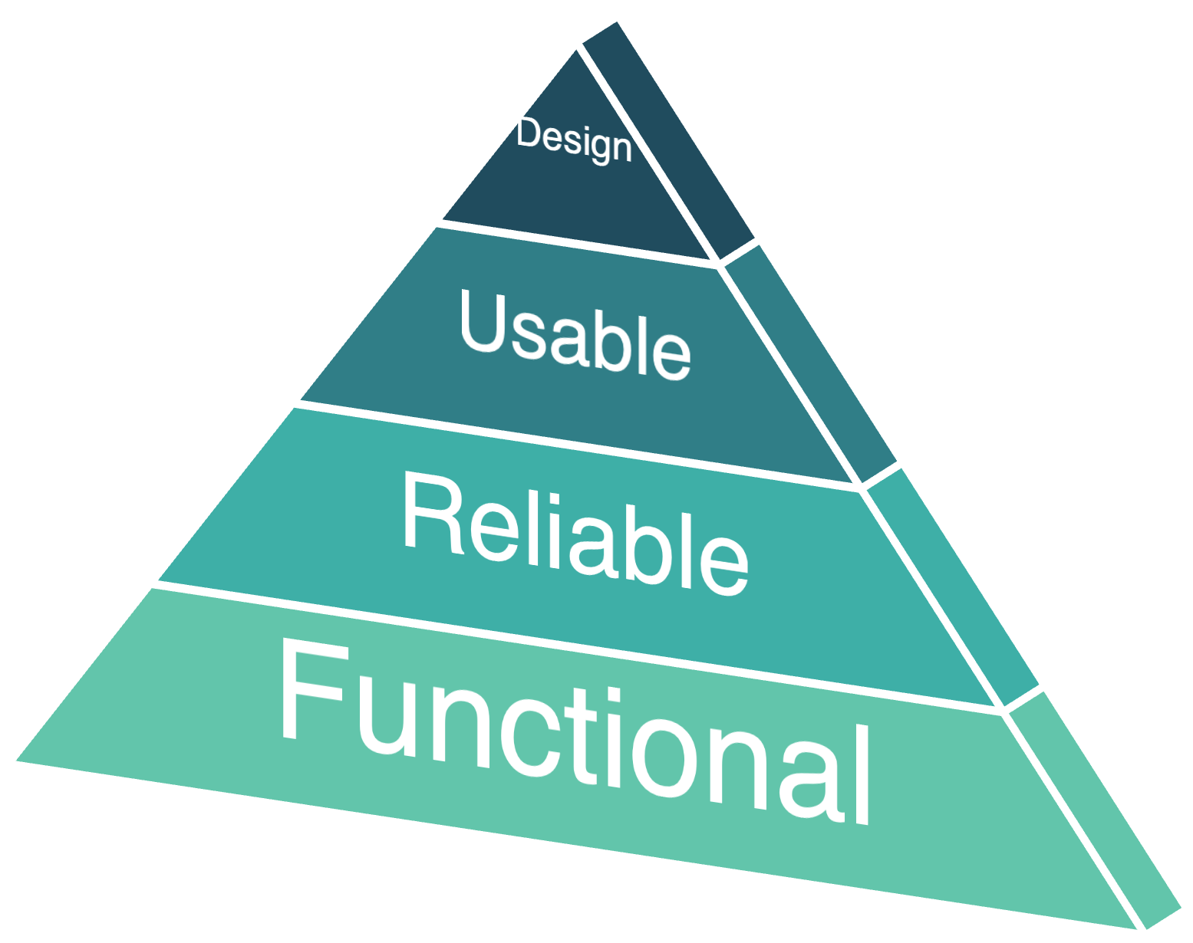

|  |
| --- |
| Iterative design would allow other modules or features to be added in the near future that suits the upcoming requirements |
| The predicted output would be helpful not only to the farmers but also to people in other sectors |
| Features are selected from authenticated data and scaled to predict with high accuracy |
| Region or zone-based rainfall prediction for prior decision making and planning |

Diagrammatic Structure of MVP:

Visualization

Data Analysis

Rainfall Data [.csv file]

Dashboard

feature selection & extraction

Rainfall Prediction Window

User Inputs

Information Centre [Home Page]

Algorithm

display

train & test

Data Preprocessing

User feedback & support



User guide & other information

User Interface

Predicted Output

Model